The Old Bakery Danehill Village Centre

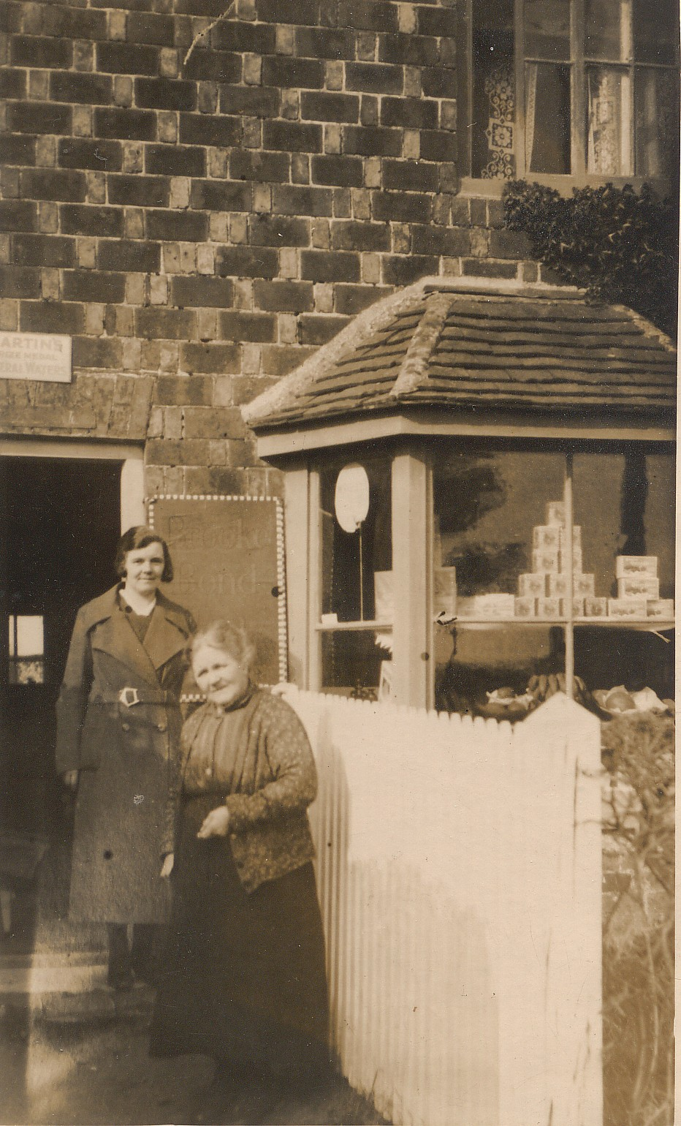
Mrs Turner and her daughter, Nellie (Randall) outside the Bakery. Then called Turner’s Bakery
A date of about 1940 has been suggested

The Bakery and cottage were built as a pair between 1872 & 1878, on land that had previously belonged to The Red Lion, later to be named The White House. The man who built the Bakery and the adjacent cottages was William Terry, the tenant of Haven/Heaven Farm, Furners Green, between 1873 & 1881. His daughter, Sarah, married Spencer Huggett, the -grandfather of Maurice and David Huggett of Portmansford Farm, Furners Green. There is a strong tradition in the Huggett family that William Terry built the bakehouse for his daughter Annie, who, whilst out in service as a cook-housekeeper married the butler and that later they worked at a big house in Ireland. The marriage was unhappy and Annie left him and with her little boy came back from Ireland to Haven Farm.
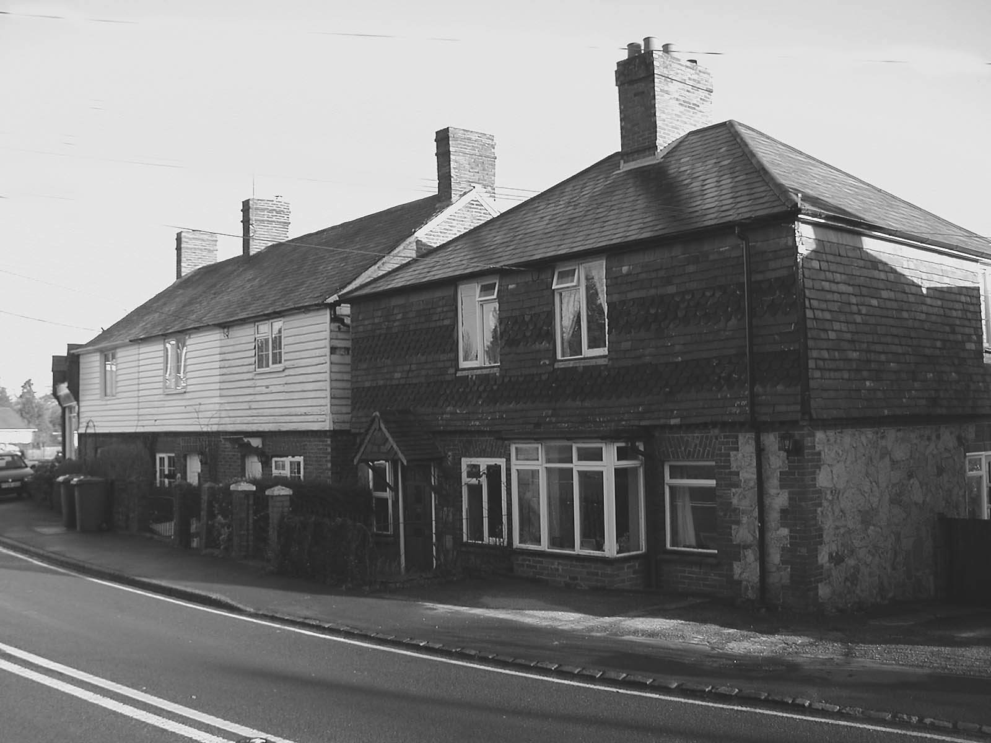
Could use this one

Mrs Ann Wilson was the first Baker, from c.l878-1891.Was she Annie Terry? Ann Wilson died in August 1891 and is buried at Danehill. To quote the census returns for Danehill 1881 & 189I “4 Rose Cottages. Ann Wilson, widow, Master Baker, aged 47 [1881] born Surrey, parish unknown. Robert W. Wilson, son, scholar, aged 12. [1881], Baker, 22 [1891] born Dublin, Ireland”. Despite extensive searches there is still no clue as to her parentage, or to any connection with the Huggett or Terry families.
The next baker was Alonzo Cox from c. 1894 until 1936, he died in 1937, aged 84.
Dame Margery Corbett Ashby [1882-1981] vividly remembered Mr Cox and his horse. “He was such a nice man and he had such a lovely horse. 1 admired that horse excessively.” This photograph of a neat, trim Alonzo Cox in his well-painted delivery van, a splendid bay pony between the shafts. It was probably a successor to the horse that five-year old Margery remembered but again, a very fine animal.

Mrs Cox, an apple cheeked Somerset born lady served in the shop, In addition to bread and cakes sweets and chocolate were on sale, even a farthings worth was available, wrapped in hand made blue paper bags.

A. J. Newnham who previously had the butcher’s and grocer’s shops at The White House (29) in the 1920s came to help out his ailing old friend, Alonzo Cox. When A.J Newnham took over the business in 1937 a Ford motor van replaced the pony and trap. In 1947 his brother E. C. Newnham and his wife took over the business with Mr Cooper as the baker. William G. Cottenham took over the Bakery in 1951 and employed Colin Lucas as a roundsman.

Following the retirement of Mr Cottenham in 1979 the property and business was purchased by Mrs Reardon. Finding it difficult to find a skilled baker Mrs Reardon tried buying in bread and cakes, unfortunately the business steadily declined and was closed down after Christmas in 1980. Notes written by Hylda Rawlings.

A date of 1935 has been suggested for this photo. (probably much earlier)

