From “Sussex County Magazine” date ?? page 110

AN ARTIST IN IRONWORK. By C. E. TRITTON

SUSSEX is the poorer by the death last December of Mr. George Etherton of Danehill. He was genuine craftsman of the old school, worthy of the dignity and honour of the name, such as it is all too rare today; to him, indeed, the designation of artist is not inappropriate.
He came of an old Sussex family, and his forge was known for miles around as a place where good workmanship was assured. Specimens of his handicraft have been exhibited all over Sussex and many a country house has some of his work in it – fire backs, fire dogs and baskets, door latches and knockers - no two alike, and adorned with flowers, fir cones, birds or family crests.

At the wonderful "Pageant of Ashdown Forest " in 1929 his skill as chief smith brought him into great prominence. Here is what the Duchess of York wrote afterwards to Mr. W. Hambro, of Kidbrooke Park: -

"I should be glad if you would tell Mr Etherton of Dane Hill how much I appreciate the rose he has wrought in iron for me. I think that the design has been most beautifully carried out. I think it was very clever of him to do a lily and a bird during the performance for you and Lord Edward Gleichen."

How did this village blacksmith acquire his exceptional skill? Of course he " had it in him," as one says, from his youth. As a lad, and working, as all smiths did years ago, from six in the morning till seven of a summer's evening, with an extra three hours making new horseshoes out of old ones in the winter, he was never satisfied with the ordinary routine work.. Neither long hours nor poor pay damped his ardour for metal work, and he experimented in all sorts of ways and made all sorts of articles, beginning at the age of ten with a small steam engine.

He was entirely self taught as far as design and artistic work went, and usually worked " out of his head," without models and, at most, a rough pencil sketch. If he were given an idea of what was wanted he would produce it with great dexterity.
He attributed his skill to his experience, many years ago, as a coach builder, which demanded a very high standard of iron work, and, above all, to the work of making new shoes from old in those winter evenings.

He maintained that in since smiths have ceased to make these, the trade has ceased to make real smiths, because it was by "taking heats "- that is by bringing the old metal to the exact temperature required for welding it nicely and securely together-that they became masters of their art.

He had a fine scorn for machine-made and malleable iron work, and greatly deplored the rarity nowadays of the beautiful music of the "double hammer" when two men with their heavy sledges struck the hot iron in turn while smith directed their blows with occasional taps from his small hammer.

But while lamenting the passing of old methods, Mr Etherton paid high tribute to work of the Farriery Instructors who, since war, have been appointed throughout the county. Had it not been for the help he received from this direction, he said that he would not have carried off the championship cup and medal at the Hastings Agricultural Show in a two day contest.

The trade at present does not attract keenest and most capable workers, and men of George Etherton's type and skill can ill spared.

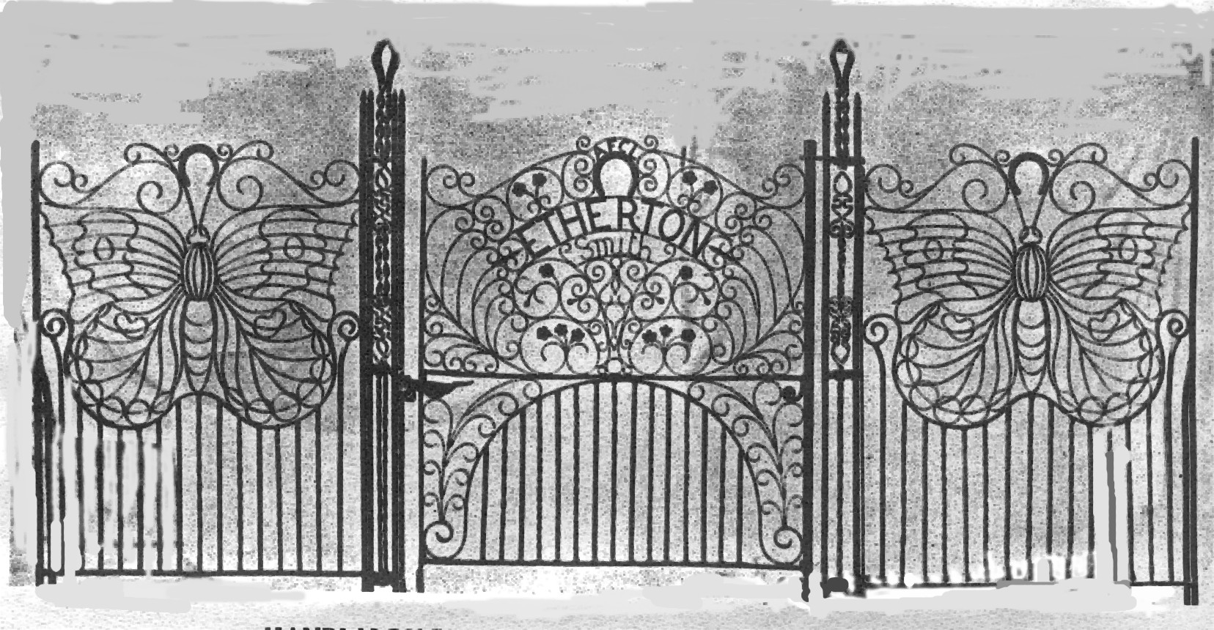

Butterfly Gates designed and made by George Etherton
exhibited at Olympia

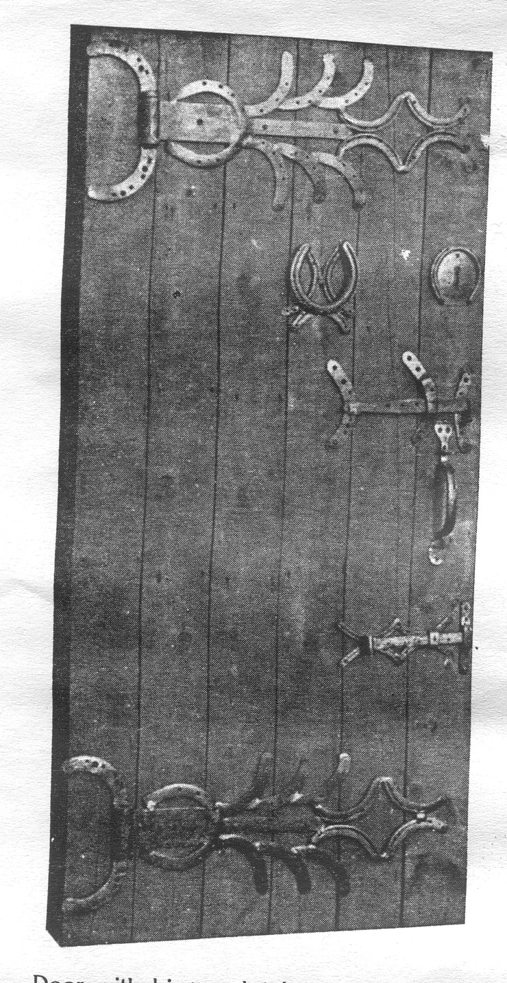
Door made with hinges, latches and knocker
made from old horse shoes, by George Etherton.

